**BANK LOAN REPORT QUERY DOCUMENT**

1. **BANK LOAN REPORT | SUMMARY**

**KPI’s:**

**Total Loan Applications**

SELECT COUNT(id) AS Total_loan_applications FROM bank_loan_data



**MTD Loan Applications**

SELECT COUNT(id) AS MTD_loan_applications FROM bank_loan_data

WHERE MONTH(issue_date) = 12 AND YEAR(issue_date) = 2021



**PMTD Loan Applications**  
SELECT COUNT(id) AS PMTD_loan_applications FROM bank_loan_data

WHERE MONTH(issue_date) = 11 AND YEAR(issue_date) = 2021



**MOM**

SELECT (m.MTD_loan_app - p.PMTD_loan_app)* 1.0 / p.PMTD_loan_app * 100 AS MOM

FROM

(SELECT COUNT(id) AS MTD_loan_app FROM bank_loan_data WHERE MONTH(issue_date) = 12) AS m,

(SELECT COUNT(id) AS PMTD_loan_app FROM bank_loan_data WHERE MONTH(issue_date) = 11) AS p

**Total Funded Amount**

SELECT SUM(loan_amount) AS Total_Funded_amount FROM bank_loan_data



**MTD Total Funded Amount**

SELECT SUM(loan_amount) AS MTD_Total_Funded_amount FROM bank_loan_data

WHERE MONTH(issue_date) = 12 AND YEAR(issue_date) = 2021



**PMTD Total Funded Amount**

SELECT SUM(loan_amount) AS PMTD_Total_Funded_amount FROM bank_loan_data

WHERE MONTH(issue_date) = 11 AND YEAR(issue_date) = 2021



**Total Amount Received**

SELECT SUM(total_payment) AS Total_Amount_received FROM bank_loan_data



**MTD Total Amount Received**

SELECT SUM(total_payment) AS MTD_Total_Amount_received FROM bank_loan_data

WHERE MONTH(issue_date) = 12 AND YEAR(issue_date) = 2021



**PMTD Total Amount Received**

SELECT SUM(total_payment) AS PMTD_Total_Amount_received FROM bank_loan_data

WHERE MONTH(issue_date) = 11 AND YEAR(issue_date) = 2021



**Average Interest Rate**

SELECT ROUND(AVG(int_rate), 4) * 100 AS AVG_Interest_rate FROM bank_loan_data



**MTD Average Interest**

SELECT ROUND(AVG(int_rate), 4) * 100 AS MTD_AVG_Interest_rate FROM bank_loan_data

WHERE MONTH(issue_date) = 12 AND YEAR(issue_date) = 2021



**PMTD Average Interest**

SELECT ROUND(AVG(int_rate), 4) * 100 AS PMTD_AVG_Interest_rate FROM bank_loan_data

WHERE MONTH(issue_date) = 11 AND YEAR(issue_date) = 2021



**Avg DTI**

SELECT ROUND(AVG(dti), 4) * 100 AS Avg_DTI FROM bank_loan_data



**MTD Avg DTI**

SELECT ROUND(AVG(dti), 4) * 100 AS MTD_Avg_DTI FROM bank_loan_data

WHERE MONTH(issue_date) = 12 AND YEAR(issue_date) = 2021



**PMTD Avg DTI**

SELECT ROUND(AVG(dti), 4) * 100 AS PMTD_Avg_DTI FROM bank_loan_data

WHERE MONTH(issue_date) = 11 AND YEAR(issue_date) = 2021



**GOOD LOAN ISSUED**

**Good Loan Percentage**

SELECT

(COUNT(CASE WHEN loan_status = 'Fully Paid' OR loan_status = 'Current' THEN id END) * 100)

/

COUNT(id) AS Good_loan_percentage

FROM bank_loan_data



**Good Loan Applications**

SELECT COUNT(id) AS Good_loan_Applications FROM bank_loan_data

WHERE loan_status = 'Fully Paid' OR loan_status = 'Current'



**Good Loan Funded Amount**

SELECT SUM(loan_amount) AS Good_loan_Funded_amount FROM bank_loan_data

WHERE loan_status = 'Fully Paid' OR loan_status = 'Current'



**Good Loan Amount Received**

SELECT SUM(total_payment) AS Good_loan_Received_amount FROM bank_loan_data

WHERE loan_status = 'Fully Paid' OR loan_status = 'Current'



**BAD LOAN ISSUED**

**Bad Loan Percentage**

SELECT

(COUNT(CASE WHEN loan_status = 'Charged Off' THEN id END) * 100)

/

COUNT(id) AS Bad_loan_percentage

FROM bank_loan_data



**Bad Loan Applications**

SELECT COUNT(id) AS Bad_loan_applications FROM bank_loan_data

WHERE loan_status = 'Charged Off'



**Bad Loan Funded Amount**

SELECT SUM(loan_amount) AS Bad_loan_Funded_amount FROM bank_loan_data

WHERE loan_status = 'Charged Off'

**Bad Loan Amount Received**

SELECT SUM(total_payment) AS Bad_loan_Received_amount FROM bank_loan_data

WHERE loan_status = 'Charged Off'



**LOAN STATUS**

SELECT loan_status,

COUNT(id) AS Total_loan_applications,

SUM(loan_amount) AS Total_Funded_amount,

SUM(total_payment) AS Total_amount_Received,

AVG(int_rate) * 100 AS Avg_interest_rate,

AVG(dti) * 100 AS Avg_DTI

FROM bank_loan_data

GROUP BY loan_status

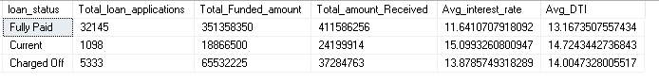

SELECT loan_status,

SUM(loan_amount) AS MTD_total_Funded_amount,

SUM(total_payment) AS MTD_total_amount_Received

FROM bank_loan_data

WHERE MONTH(issue_date) = 12

GROUP BY loan_status

**B. BANK LOAN REPORT | OVERVIEW**

**MONTH**

SELECT MONTH(issue_date) AS Month_Number,

DATENAME(MONTH, issue_date) AS Month_Name,

COUNT(id) AS Total_loan_Applications,

SUM(loan_amount) AS Total_Funded_Amount,

SUM(total_payment) AS Total_Received_Amount

FROM bank_loan_data

GROUP BY MONTH(issue_date), DATENAME(MONTH, issue_date)

ORDER BY MONTH(issue_date)

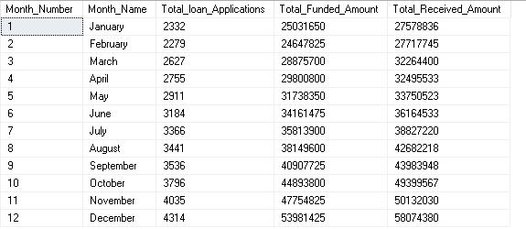

**TERM**

SELECT term AS Loan_Term,

COUNT(id) AS Total_loan_Applications,

SUM(loan_amount) AS Total_Funded_Amount,

SUM(total_payment) AS Total_Received_Amount

FROM bank_loan_data

GROUP BY term

ORDER BY term

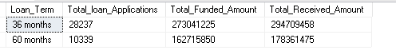

**STATE**

SELECT address_state,

COUNT(id) AS Total_loan_Applications,

SUM(loan_amount) AS Total_Funded_Amount,

SUM(total_payment) AS Total_Received_Amount

FROM bank_loan_data

GROUP BY address_state

ORDER BY SUM(loan_amount) DESC

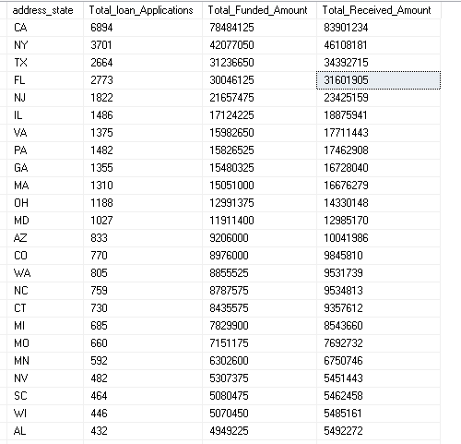

**EMPLOYEE LENGTH**

SELECT emp_length AS Emp_length,

COUNT(id) AS Total_loan_Applications,

SUM(loan_amount) AS Total_Funded_Amount,

SUM(total_payment) AS Total_Received_Amount

FROM bank_loan_data

GROUP BY emp_length

ORDER BY COUNT(id) DESC

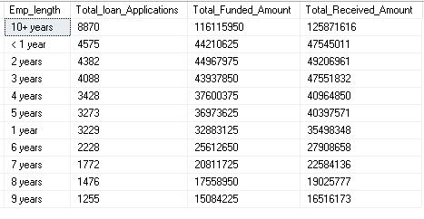

**PURPOSE**

SELECT purpose,

COUNT(id) AS Total_loan_Applications,

SUM(loan_amount) AS Total_Funded_Amount,

SUM(total_payment) AS Total_Received_Amount

FROM bank_loan_data

GROUP BY purpose

ORDER BY COUNT(id) DESC

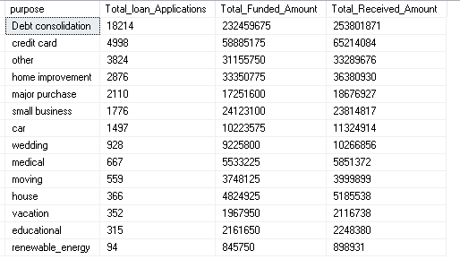

**HOME OWNERSHIP**

SELECT home_ownership,

COUNT(id) AS Total_loan_Applications,

SUM(loan_amount) AS Total_Funded_Amount,

SUM(total_payment) AS Total_Received_Amount

FROM bank_loan_data

GROUP BY home_ownership

ORDER BY SUM(loan_amount) DESC

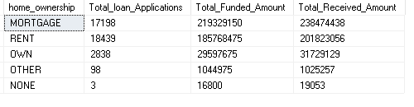

*Note: We have applied multiple Filters on all the dashboards.*

*See the results when we hit the Grade A in the filters for dashboards.*

SELECT purpose,

COUNT(id) AS Total_loan_Applications,

SUM(loan_amount) AS Total_Funded_Amount,

SUM(total_payment) AS Total_Received_Amount

FROM bank_loan_data

WHERE grade = 'A' AND address_state = 'TX'

GROUP BY purpose

ORDER BY SUM(loan_amount) DESC

